Physical science

🌍 Definition
# Source: Wiki source: Provided by: [Data Path: Persons Table -> ID Column: 1, Name_En Column: Motasem Essam] -> From: [Data Path: Sources Table -> ID Column: 244, Content Title Column: Wiki Source - Physical Sciences] -> at: [Document, page: 1, Top, “Physical science is…the "physical sciences".[1]”] on [10/27/2025]
Physical science is a branch of natural science that studies non-living systems, in contrast to life science. It in turn has many branches, each referred to as a "physical science", together called the "physical sciences".[1]
# Source: AI Source: Provided by: [Data Path: Persons Table -> ID Column: 1, Name_En Column: Motasem Essam] -> From: [Chatgpt (GPT‑5 Mini)] on [10/27/2025]
Physical science is the systematic study of the non-living components of the universe — including matter, energy, space, and time — and the laws that govern their behavior.
It seeks to understand how the universe works, from the tiniest particles (like atoms) to the largest structures (like galaxies).

🧪 Main Branches of Physical Science
# Source: AI Source: Provided by: [Data Path: Persons Table -> ID Column: 1, Name_En Column: Motasem Essam] -> From: [Chatgpt (GPT‑5 Mini)] on [10/27/2025]
Physical science has four main traditional branches:
1. Physics
- Focus: The study of matter, energy, and their interactions.
- Key topics:
  - Motion, forces, and energy
  - Waves, light, and sound
  - Electricity and magnetism
  - Quantum mechanics, relativity
- Example question: Why does a ball fall to the ground? (Gravity)

2. Chemistry
- Focus: The study of composition, structure, and properties of matter, and how substances interact and change.
- Key topics:
  - Atoms, molecules, and chemical bonds
  - Chemical reactions and equations
  - Acids, bases, and solutions
  - Thermochemistry
- Example question: What happens when iron rusts?

3. Astronomy
- Focus: The study of celestial objects (like stars, planets, comets, galaxies) and the universe as a whole.
- Key topics:
  - Origin and evolution of the universe (cosmology)
  - Planetary systems and exoplanets
  - Telescopes and space exploration
- Example question: How do stars form and die?

4. Earth Science
- Focus: The study of Earth’s structure, composition, and processes.
- Key subfields:
  - Geology (rocks, minerals, earthquakes, volcanoes)
  - Meteorology (weather and climate)
  - Oceanography (oceans and currents)
- Example question: What causes earthquakes?

🔬 Sub-disciplines and Related Fields
# Source: AI Source: Provided by: [Data Path: Persons Table -> ID Column: 1, Name_En Column: Motasem Essam] -> From: [Chatgpt (GPT‑5 Mini)] on [10/27/2025]
Physical science overlaps with other scientific areas, leading to hybrid fields such as:
- Biophysics: applying physics to biological systems
- Geochemistry: chemistry of Earth materials
- Astrophysics: physics of stars and space
- Physical Chemistry: the physical principles behind chemical reactions

⚙️ Scientific Methods Used in Physical Science
# Source: AI Source: Provided by: [Data Path: Persons Table -> ID Column: 1, Name_En Column: Motasem Essam] -> From: [Chatgpt (GPT‑5 Mini)] on [10/27/2025]
- Observation – Noticing phenomena (e.g., falling objects, reactions)
- Hypothesis – Proposing explanations
- Experimentation – Testing ideas under controlled conditions
- Data Analysis – Interpreting results with logic and math
- Theory & Law Formation – Developing explanations (e.g., Newton’s Laws, Atomic Theory)

📏 Importance of Physical Science
# Source: AI Source: Provided by: [Data Path: Persons Table -> ID Column: 1, Name_En Column: Motasem Essam] -> From: [Chatgpt (GPT‑5 Mini)] on [10/27/2025]
- Explains natural laws: Why and how things move, react, or change.
- Drives technology: Foundations of engineering, medicine, energy, and communication.
- Predicts phenomena: Weather forecasting, space missions, nuclear energy.
- Supports other sciences: Chemistry and physics principles underlie biology, geology, and environmental science.

⚡ Examples in Daily Life
# Source: AI Source: Provided by: [Data Path: Persons Table -> ID Column: 1, Name_En Column: Motasem Essam] -> From: [Chatgpt (GPT‑5 Mini)] on [10/27/2025]
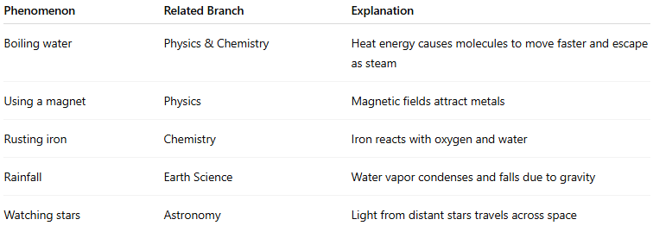
Phenomenon | Related Branch | Explanation
Boiling water | Physics & Chemistry | Heat energy causes molecules to move faster and escape as steam
Using a magnet | Physics | Magnetic fields attract metals
Rusting iron | Chemistry | Iron reacts with oxygen and water
Rainfall | Earth Science | Water vapor condenses and falls due to gravity
Watching stars | Astronomy | Light from distant stars travels across space

🧭 Summary
# Source: AI Source: Provided by: [Data Path: Persons Table -> ID Column: 1, Name_En Column: Motasem Essam] -> From: [Chatgpt (GPT‑5 Mini)] on [10/27/2025]

Aspect | Description
Main Focus | Non-living systems — matter, energy, and natural laws
Branches | Physics, Chemistry, Astronomy, Earth Science
Goal | To understand how the physical universe behaves
Method | Observation → Experiment → Theory → Law
Applications | Technology, engineering, environment, medicine, and space

